Língua Portuguesa Profª Stefanie Moreira Redação Diagnóstica
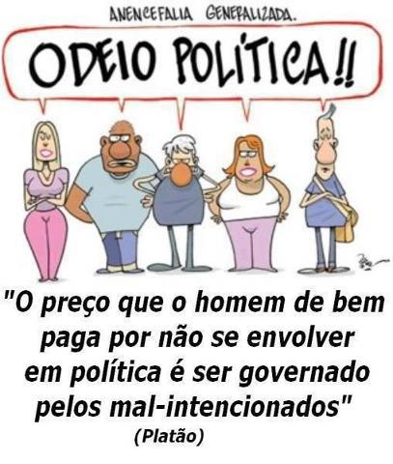
Nome:___________________________________ 1K 15/08/2014
Adolescente não gosta, não se interessa, não sabe e não se importa com política,
você concorda? Escreva uma redação de no mínimo 20 e no máximo 35 linhas
em que você se posiciona argumentativamente diante desta questão.
_________________________________________________
__________________________________________________________________________________________________________________________________________________________________________________________________________________________________________________________________________________________________________________________________________________________________________________________________________________________________________________________________________________________________________________________________________________________________________________________________________________________________________________________________________________________________________________________________________________________________________________________________________________________________________________________________________________________________________________________________________________________________________________________________________________________________________________________________________________________________________________________________________________________________________________________________________________________________________________________________________________________________________________________________________________________________________________________________________________________________________________________________________________________________________________________________________________________________________________________________________________________________________________________________________________________________________________________________________________________________________________________________________________________________________________________________________________________________________________________________________________________________________________________________________________________________________________________________________________________________________________________________________________________________________________________________________________________________________________________________________________________________________________________________________________________________________________________________________________________________________________________________________________________________________________________________________________________________________________________________________________________________________________________________________________________________________________________

